Referral Pathway for

Child Sexual Abuse / Assault Forensic Medical Assessment

The aim of a medical assessment is to meet the medical/sexual health and forensic needs of the child/young person. If there are concerns about sexual abuse, sending patients to the Emergency Department (A&E dept) or GP is never appropriate unless they are medically unwell. See flow chart below for appropriate service.

Video of what to expect when you visit a Child Sexual Assault Assessment Centre Acer House CSAAS

In pediatric services:

- Children and young people are rarely seen in the middle of the night, as this is not in their best interest, in line with the Faculty of Forensic and Legal Medicine (FFLM) and Royal College of Paediatrics and Child Health (RCPCH) guidance.
- Speculums are never used in examinations of pre-pubertal children.
- The children/young people & carers are always able to stop the assessment at any time and are offered age-appropriate distraction techniques during the process, which is done in a sensitive and unhurried way.
- Children and Young people can be seen who are aged 0 – 16 years old and 16 – 18 years old (up to their 19th birthday) if:
  - The young person has special educational needs or disabilities, where deemed to be clinically appropriate, for both Acute (up to 14 days of the alleged incident) and non-recent (after 14 days since the alleged incident) cases.
- Young people 16 years or older, & not in the categories above, are seen by Adult Sexual Assault Referral Centre (SARC) service.
- For the Acute service, children 13 years and over will be offered to be seen in the Adult Sexual Assault Referral Centre (SARC) if deemed to be clinically appropriate during triage.
- Professionals can support children and their families to access resources about the Child Sexual Assault Assessment Service (CSAAS) service through these online resources Helpful Resources - Acer House.

Should at any point there be a difference in professional perspectives that cannot be resolved, partners are encouraged to follow the relevant resolution guidance for North Yorkshire or City of York.

Referral Process Pathway
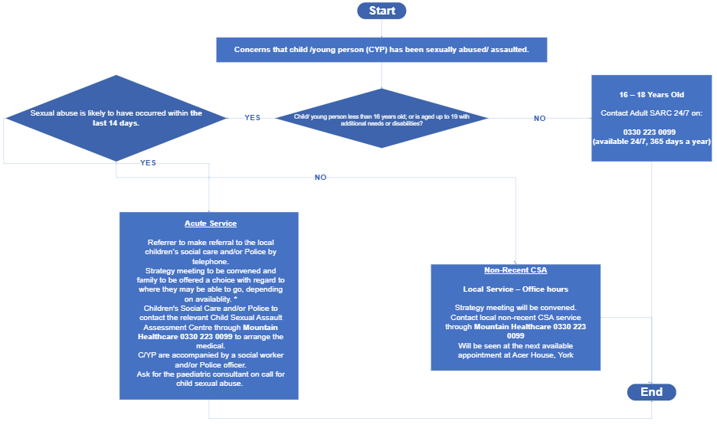

*All children and young people in North Yorkshire who require an acute child sexual assault examination must be referred to Mountain Healthcare (0330 223 0099), who act as the single point of coordination. Mountain Healthcare will complete the triage, discuss the case with Police and Children’s Social Care as part of the strategy discussion, they would then agree the approach that is in the child’s best interests, taking into account clinical priorities and forensic timescales. Referrers must not arrange examinations directly. Mountain Healthcare will confirm the triage outcome and the examination arrangements with the referrer.

Children and young people will usually be seen at Acer House (York) or Hazelhurst Centre (Morely, West Yorkshire), depending on capacity. In exceptional circumstances and where required to meet forensic timescales or best-interest considerations, Mountain Healthcare may arrange attendance at an alternative Child Sexual Assault Assessment Service, such as the South Yorkshire service provided by Sheffield Children’s Hospital or the Newcastle Child Sexual Assault Assessment Service provided by the Royal Victoria Infirmary. Use of any alternative sites (e.g., Sheffield or Newcastle) remains exceptional and subject to availability, best interest considerations and will follow clinical decisions made at triage.

