Child Exploitation Awareness Day 2026

Partnership Communications Pack
18 March 2026 | #CEADay26
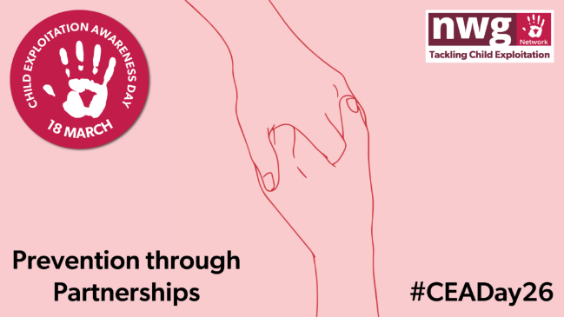
On 18 March 2026, partners across North Yorkshire are asked to support National Child Exploitation Awareness Day, led by the NWG Network. The national theme this year is preventing abuse through exploitation by working in partnership, reinforcing that safeguarding children is a shared responsibility across agencies, communities and the wider public.
Child exploitation is a form of abuse where children and young people are manipulated, coerced, threatened or groomed into sexual or criminal activity. Children are always victims, and exploitation can happen online or in the physical places and spaces where children spend their time.
Key partnership messages
Below are some of the key partnership messages that we would like partners to share and promote across teams and networks: (Hyperlinks take you to supporting documents).
- Child exploitation is happening in North Yorkshire, and all children can be vulnerable.
- We all have a role in spotting concerns, sharing information and disrupting harm.

- Professional curiosity matters; every interaction is an opportunity to notice change and act early.
- Sharing intelligence with the police and partners is one of the most effective ways to disrupt exploitation.
- Children and young people cannot consent to exploitation – the language we use matters to ensure children are seen as the victim and never blamed.

How partners can support CEADay 2026
Partners are encouraged to:
- Share CEADay messages across social media, websites, newsletters and intranets. Follow us on Facebook and Instagram, and like and share messages throughout the week.
- Cascade key messages to frontline staff and volunteers.
- Promote the NWG Helping Hands pledge and national hashtags. Homepage - STOP CE -
- Share and signpost local and national learning, guidance and resources.
- Use CEADay as a prompt to refresh knowledge and discuss exploitation within teams.
Resources:
To mark CEAday26, the partnership is launching the Multi-Agency Child Exploitation (MACE) quick guide. Multi Agency Child Exploitation
The guide provides an easy access summary of key messages and resources, alongside links to further training and information to find out more about child exploitation.
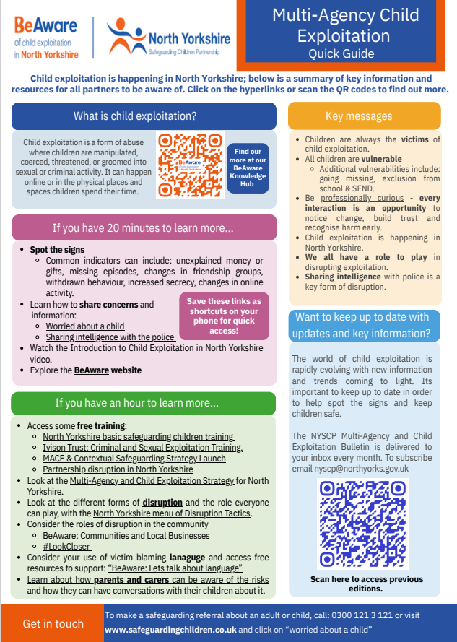

Further resources are available via the NYSCP BeAware Knowledge Hub and are highlighted in the March NYSCP and MACE newsletter
Training:
A range of training is detailed to partners in the March NYSCP & MACE bulletin, including from the National Working Group, The Long Game, Barnardo’s and the Children’s Society.
NYSCP will also be supporting the delivery of two free virtual events, which can be accessed by clicking on the Teams Link:
Social media and emojis - uncracking the code to tackle exploitation. 18th March 12:00 – 13:00
Delivered by Gemma Ohr, this one-hour session is designed for anyone seeking a deeper understanding of how exploitation occurs online in relation to drug sales, the concerning applications being used, and what online drug dealing typically looks like.
The session will examine why social media platforms are being utilised for drug supply and how emojis and specific language are used to facilitate this. It will also highlight keyways to help young people stay safe when navigating these online spaces.
Further links to sources of help and assistance will also be shared alongside the Be Aware site and the North Yorkshire Police Intelligence portal link.
This is a free session that can be accessed through the following Teams link:
Join: https://teams.microsoft.com/meet/35914076461043?p=duGbNTqH3e6VvlaVJC
Meeting ID: 359 140 764 610 43
Passcode: MR2oL794

North Yorkshire Police: Virtual reality of knife crime - ground-breaking tech to keep young people safe 19th March 12:00 – 12:30
In this free 30-minute online session, North Yorkshire Police will share information relating to the use of an immersive 360-degree film that aims to build an emotional understanding of the devastating impact of knife crime among children and young people. “One knife destroys more than one life” is delivered to young people through VR headsets, with the viewer witnessing a tragic incident from multiple perspectives, stepping into the shoes of everyone affected.
The session is delivered via Teams on 19th March 12:00 - 12:30 and can be accessed on the following link:
Microsoft Teams meeting
Join: https://teams.microsoft.com/meet/32083767805362?p=vcFPZ02DOCRBnRcV56
Meeting ID: 320 837 678 053 62
Passcode: n5D7Re2r
_____________________________________________________________
Events:
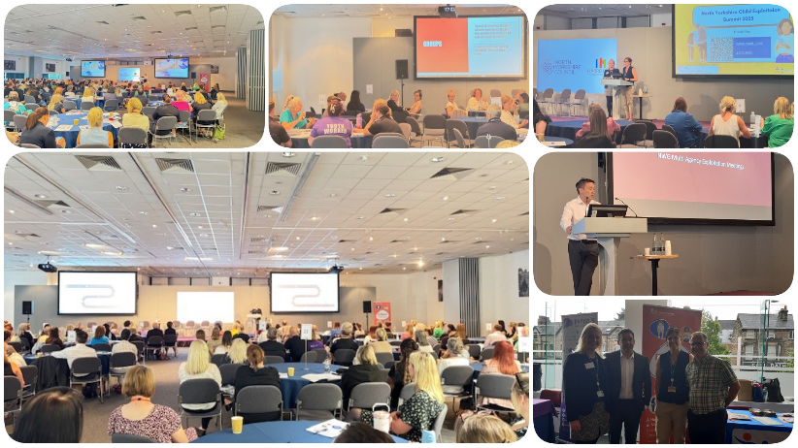

Following the successful multi-agency child Exploitation summit in summer 2025, North Yorkshire Safeguarding Children Partnership and Safer North Yorkshire are pleased to announce the summit will be returning on 22nd June 2026, 09:00 – 16:30 at Harrogate Convention Centre.
This FREE summit will be an opportunity for partners from across North Yorkshire to come together to look at how we can work together to tackle exploitation and serious youth violence, exploring the experiences of those directly involved in it.
With various enlightening and empowering keynote speakers and workshops throughout the day, the summit will prove to be an incredible occasion to come together as North Yorkshire Partners to tackle exploitation and serious youth violence.
Audience: We welcome frontline practitioners and managers to attend from across all agencies who work in North Yorkshire with young people (ages 8 and above) and their families. Due to the demand for tickets, we please request that those attending commit stay for the whole day and that any cancellations are submitted within 7 days of the event.
There is an expectation that attendees will have a basic understanding of Child Exploitation and the Multi-Agency Child Exploitation processes in North Yorkshire, which can be accessed by reading the following practice guidance from NYSCP. A short “Introduction to Child Exploitation in North Yorkshire”
Booking Details will be made available via the NYES website and via the Learning Zone for Local Authority Colleagues on 18th March 2025.
Look out for further details on our social media pages and the NYSCP website.

Thank you for your continued support of CEAday and tackling
Child Exploitation in North Yorkshire.

