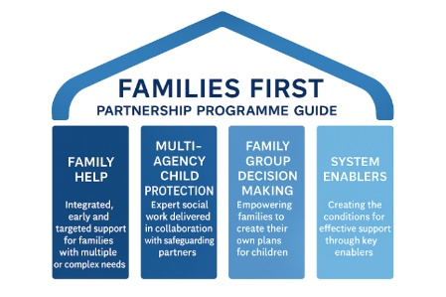
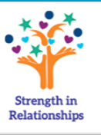
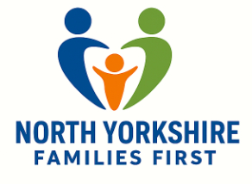
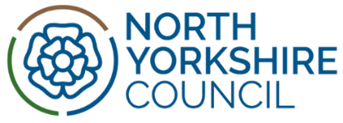
Strength in
Relationships

North Yorkshire Families First Implementation
We are very excited to launch our North Yorkshire Task and Finish Groups! Meetings will take place every two weeks for each of the pillars.
Your Pillar lead is inviting you to your first Task and Finish Group. We appreciate your time is valuable and will be grateful if you can prioritise these meetings.
Thank you

What is Families First and why does it matter?
As you will be aware, the Families First Partnership Programme is a national initiative designed to rebalance children’s social care towards earlier, preventative support. Families First promotes Family Help, delivered by multi-disciplinary teams, and establishes Multi-Agency Child Protection Teams to ensure timely, coordinated responses to risk. It also embeds Family Group Decision Making, empowering families to shape solutions.

By fostering joint decision-making, shared information, and co-designed interventions, Families First will strengthen multi-agency collaboration, making our Task and Finish Groups a vital mechanism for driving these changes locally.


Why join a Task and Finish Group?
Click on the QR code to access the shared learning page at NYSCP
- Contribute to shaping North Yorkshire’s approach to family help and safeguarding.
- Work collaboratively across agencies to deliver practical solutions.
- Share expertise and learn from others in a focused, action-driven environment.

Each Task and Finish Group will focus on a key area of transformation:

Our six areas below build on the four national  pillars of the Families First Programme | Leads | Contact email address
Family Help  Driving early, preventative support for families | - David Sharp  - Barbara Merrygold | David@nyy.org.uk  Barbara.Merrygold@northyorks.gov.uk
Multi-Agency Child Protection Team  Risk Outside the Home  Strengthening Multi-Agency Child Protection Teams and Routes of Help | - Emma Hopper  - Emma Phillips  - Donna Musgrove | Emma.Hopper@northyorks.gov.uk  Emma.Phillips@northyorks.gov.uk  Donna.Musgrove@northyorkshire.police.uk
Family Network Decision Meetings  Embedding family-led decision-making | - Joanna Miles  - Adele Herdsman | Joanna.Miles@northyorks.gov.uk  Adele.Herdsman@northyorks.gov.uk
Kinship  Supporting kinship care arrangements | - Rosie Appleby  - Kate Reid | Rosie.Appleby@northyorks.gov.uk  Kate.Reid@northyorks.gov.uk
System Change  Leading innovation and process improvement | - Samantha Clayton  - Tom Pick | Samantha.Clayton@northyorks.gov.uk  Tom.Pick@northyorks.gov.uk
Communications  Engagement and Workforce  Building a strong, informed, and connected workforce | - Samantha Clayton  - Health - ICB | Samantha.Clayton@northyorks.gov.uk  To be confirmed
We would like to take this opportunity to thank you for being part of this exciting new approach to improving outcomes for children and families in North Yorkshire. Your involvement is key to making a real difference.

