**Briefing Pack for Partners**

**Hate Crime Awareness Week**

**Monday 13th October – Friday 17th October 2025**

**North Yorkshire and City of York**

**What is Hate Crime Awareness Week 2025**

Hate Crime Awareness Week is a national week **(11th October – 18th October 2025)** of action to encourage local authorities, key partners and communities affected by hate crime to work together to tackle local hate crime issues.

The York and North Yorkshire Inclusive Communities Joint Coordinating Group, will utilise this week, **Monday 13th October – Friday 17th October** to,

* Raise awareness of hate crime.
* Build trust in our services and confidence to report hate crime, whilst also promoting a diverse and inclusive workforce and community.
* Promote support services available to those who may suffer incidents of Hate Crime in North Yorkshire and the City of York.

This is supported by the Community Safety Partnerships, Safeguarding Adults Boards and Safeguarding Children Partnerships in York and North Yorkshire.

Representatives from several organisations/partnerships have met to build on the previous year’s successful campaign in finalising proposals and plans for a coordinated social media campaign that makes use of and signposts to, existing resources.

As part of this **#HelpNotHateNY** will be used during Hate Crime Awareness Week 2025.

In North Yorkshire and the City of York, each day will focus on different key messages relating to both hate crime/disability and prevent as follows:

|  |  |
| --- | --- |
| **Date** | **Theme** |
| **Friday 10th October** | **Joint Press Release introducing HCAW and the focus for the week:**   * **What is Hate Crime** * **Build trust in our services and confidence to report hate crime by showcasing some positive outcomes** * **Promoting a diverse and inclusive workforce and community.** * **Promote support services available to those who may suffer incidents of Hate Crime in North Yorkshire and the City of York. - What support is available, i.e. Supporting Victims** |
| **Webinars can be booked via the Eventbrite links in the narrative:** | |
| **Monday 13th October** | **Northallerton Town Hall (Face to Face)**  MENCAP will be hosting the annual community engagement event on Monday 13th October between 10am-1pm. |
| **Tuesday 14th October** | **Hate Crime Champions Event at Harrogate Civic Centre**  [Hate Crime Awareness and Hate Crime Champions Session Tickets, Tue, Oct 14, 2025 at 10:00 AM | Eventbrite](https://www.eventbrite.com/e/hate-crime-awareness-and-hate-crime-champions-session-tickets-1615035888819?aff=oddtdtcreator) |
| **Wednesday 15th**  **October** | **York & North Yorkshire Hate Crime Conference – Priory Street Centre, York**  [York and North Yorkshire Hate Crime Conference 2025 Tickets, Wed, Oct 15, 2025 at 9:15 AM | Eventbrite](https://www.eventbrite.co.uk/e/york-and-north-yorkshire-hate-crime-conference-2025-tickets-1311955045859?aff=oddtdtcreator) |
| **Thursday 16th October** | **WEBINAR 1:**  **Misogyny, sexism and violence against women and girls**  **Presenter: Carmel Offord**  **Engagement Manager, IDAS**  **Time: 09:30 – 10:30**  Underpinning violence against women and girls is a spectrum of behaviours and attitudes that permeate through our society - sexism and misogyny. This workshop will look at the systems and structures that enable these to prevail and the everyday actions that embolden perpetrators of gender-based violence and abuse. The workshop will encourage discussion and aims to empower us all to think about the changes we can make to prevent violence against women and girls.  [Misogyny, sexism and violence against women and girls Tickets, Thu, Oct 16, 2025 at 9:30 AM | Eventbrite](https://eur02.safelinks.protection.outlook.com/?url=https%3A%2F%2Fwww.eventbrite.co.uk%2Fe%2Fmisogyny-sexism-and-violence-against-women-and-girls-tickets-1718380906549%3Faff%3Doddtdtcreator&data=05%7C02%7CLaura.Cobb%40northyorks.gov.uk%7Cb75e6cde5af04106fa3508ddf7550612%7Cad3d9c73983044a1b487e1055441c70e%7C0%7C0%7C638938666760554083%7CUnknown%7CTWFpbGZsb3d8eyJFbXB0eU1hcGkiOnRydWUsIlYiOiIwLjAuMDAwMCIsIlAiOiJXaW4zMiIsIkFOIjoiTWFpbCIsIldUIjoyfQ%3D%3D%7C0%7C%7C%7C&sdata=F8vCEOtBNwrlVsR%2BrGjYK%2BZCKsnU73B%2FRYA7fp2m47o%3D&reserved=0)  **WEBINAR 2:**  **Incel Subculture**  **Presenter: Sergeant Ben Hallewell.**  **Counter Terrorism Policing, North East**  **Time: 11:00 – 12:30**  This session will focus on Incel sub-culture and its deep-rooted misogynistic beliefs as well as other extreme, cultural views and its links to terrorist acts and behaviours.  [An introduction to the INCEL Subculture Tickets, Thu, Oct 16, 2025 at 11:00 AM | Eventbrite](https://www.eventbrite.co.uk/e/an-introduction-to-the-incel-subculture-tickets-1591343223419?aff=oddtdtcreator)  **WEBINAR 3:**  **Antisemitism and Extremism in 2025**  **Presenter: Alex Webster.**  **Northern, Regional Senior Manager, Community Security Trust**  **Time 13:00 – 14:30**  This session is aimed at addressing the following topics:   * the origins and history of antisemitism, and how it presents in both extremist spaces and in everyday society * the current trends of antisemitism in the UK and incident figures reported on by CST * through different examples, highlight the common tropes, themes and nuances of antisemitism to make it easier to identify and challenge   [Antisemitism and Extremism in 2025 Tickets, Thu, Oct 16, 2025 at 1:00 PM | Eventbrite](https://www.eventbrite.co.uk/e/antisemitism-and-extremism-in-2025-tickets-1591432861529?aff=oddtdtcreator) |

**Local engagement events during Hate Crime Awareness Week**

A number of local events have been arranged throughout the week by local Community Safety Hub and Neighbourhood Policing Teams:

|  |  |
| --- | --- |
| **Ryedale** | Tuesday 14th October 10-11. Drop in at Norton Free Fridge. |
| **Hambleton** | Monday 13th October 10 – 1 Northallerton Town Hall, MENCAP event. |
| **Scarborough** | Friday 17th October – 12pm onwards, Town centre business engagement.  Saturday 18th October – 10am – 2pm Alma Square. Led by the Salvation Army, supported by the Community Safety Hub, The Swift Project and the Women’s Centre. |
| **Selby** | Wednesday 15th October. Information stall and Police Officers to speak to outside Selby Abbey. |
| **Richmondshire** | Saturday 11th October. 6.30 – 7.30pm  Georgian Theatre Royal  Awareness event pre-performance in the foyer  Tuesday 14th October 10.30 - 12  ARAP (Afghan Relocation & Assistance Policy) Women’s Session. |
| **Skipton** | No planned activity. |
| **Harrogate** | Wednesday 15th October. Information stall at Ripon Market. |

**Press Releases**: An overarching press release will be issued for the week by the NYC, NYP and CYC corporate communications leads on behalf of the partnerships and boards. Lead professionals who are subject matter experts have been identified and

are being contacted by corporate communications colleagues to support information/queries around their respective areas.

**What Can You and Your Organisation Do?**

* Post Hate Crime Awareness Week 2025 content on your social media accounts (X and Facebook), for each Board and Partnership (see resources for content)
* Follow the Boards and Partnerships on X and repost their social media posts.
* North Yorkshire Community Safety Partnership: @NYorksCSP
* North Yorkshire Safeguarding Adult Board: @NYSAB1
* North Yorkshire Safeguarding Children Partnership: @NYSCP1
* City of York Safeguarding Children Partnership: [@YorkSCP](https://twitter.com/YorkSCP)
* North Yorkshire Police: @NYorksPolice
* North Yorkshire Fire & Rescue Service @NorthYorksFire
* Deputy Mayor: FB @Deputy Mayor of York and North Yorkshire, Jo Coles, Instagram @ynydeputymayor
* Combined Authority : FB @York and North Yorkshire Combined Authority
* To share Hate Crime Awareness Week 2025 posts on your social media accounts and get messages out across your networks.
* Encourage colleagues to share this briefing pack and resources for Hate Crime Awareness Week 2025 and ask them to join you in supporting Hate Crime Awareness Week 2025 campaign.
* Please don’t forget the campaign hashtags in your posts **#HelpNotHateNY**

**Link to training events:**

North Yorkshire Partnership Website: [Welcome to North Yorkshire Partnerships | North Yorkshire Partnerships](https://www.nypartnerships.org.uk/)

**Provided by North Yorkshire Learning Disability Partnership:** [**Learning Disability Partnership Board | North Yorkshire Partnerships**](https://www.nypartnerships.org.uk/learningdisabilitypartnershipboard)

* <https://www.sheffieldvoices.org.uk/uploads/downloads/SV-ScamsKL.pptx>
* [Learning Disability Hate Crime DVD - YouTube](https://www.youtube.com/watch?v=2N0OmDIoGVI)
* [https://www.sheffieldvoices.org.uk/money-workshop/](https://imsva91-ctp.trendmicro.com:443/wis/clicktime/v1/query?url=https%3a%2f%2fwww.sheffieldvoices.org.uk%2fmoney%2dworkshop%2f&umid=C31F0FE3-032F-DF06-8AE6-CAA3937D7338&auth=de41389fcd07b045c2bf0b8b6a6bb2cde097bfb7-b33bc8fdf66f3a7a5633c0f7132a1d014a028c8a)
* [https://www.sheffieldvoices.org.uk/youre-not-my-mate/](https://imsva91-ctp.trendmicro.com:443/wis/clicktime/v1/query?url=https%3a%2f%2fwww.sheffieldvoices.org.uk%2fyoure%2dnot%2dmy%2dmate%2f&umid=C31F0FE3-032F-DF06-8AE6-CAA3937D7338&auth=de41389fcd07b045c2bf0b8b6a6bb2cde097bfb7-f4a5190a2fc02b0efe35c8f9e63fcf2c92438390)

**Council City of York Adults Safeguarding Board:** [**Working to safeguard adults with care and support needs – SAB**](https://www.safeguardingadultsyork.org.uk/)

**Misogyny video resources:**

* **Enough Campaign** <https://enough.campaign.gov.uk/>
* <https://www.isthisok.org.uk/>
* <https://that-guy.co.uk/do-you-recognise-yourself-in-our-60-second-film/>
* [Refuge launches celebrity video calling for misogyny to be made a hate crime. - Refuge Charity - Domestic Violence Help](https://www.refuge.org.uk/refuge-launches-celebrity-video-calling-for-misogyny-to-be-made-a-hate-crime/)
* [EE takes a stand against sexist hate ahead of women’s Euros - More About Advertising](https://eur02.safelinks.protection.outlook.com/?url=https%3A%2F%2Fwww.moreaboutadvertising.com%2F2022%2F07%2Fee-takes-a-stand-against-sexist-hate-ahead-of-womens-euros%2F&data=05%7C01%7CAmy.Price%40northyorkshire.police.uk%7Cacbee843ed6a46a5904408da5f2987fc%7C2c84bc9193af476e9721cdad67cb3ead%7C0%7C0%7C637926929214877135%7CUnknown%7CTWFpbGZsb3d8eyJWIjoiMC4wLjAwMDAiLCJQIjoiV2luMzIiLCJBTiI6Ik1haWwiLCJXVCI6Mn0%3D%7C3000%7C%7C%7C&sdata=9Uv6mhw8ndKQffCQzdSHnT15Dq%2FguKLrKgNdtoPzUFw%3D&reserved=0)

**Active Bystander**

* **All About Respect:** Active Bystander or upstander Hate Crime[**https://allaboutrespectysj.wordpress.com**](https://allaboutrespectysj.wordpress.com)

**Partnership video**

* **Explaining hate crime in North Yorkshire** [**https://youtu.be/3deAVT8_qiE**](https://youtu.be/3deAVT8_qiE)

**Further useful links/resources for the campaign:**

* <https://educateagainsthate.com/blog/posts/hate-crime-awareness-week/>
* <https://www.supportingvictims.org/>
* <https://nationalhcaw.uk/>
* <https://hatecrime.campaign.gov.uk/>
* <https://www.report-it.org.uk/learning_disability_and_autism>
* <https://www.report-it.org.uk/files/hate-crime-what-it-is-and-how-to-support-victims-and-witnesses-2016-easy-read_1.pdf>
* <https://www.report-it.org.uk/files/hate-crime-what-it-is-and-what-to-do-about-it-2016-easy-read.pdf>
* <https://nypartnerships.org.uk/hatecrime>
* <https://www.york.gov.uk/HateCrime>
* [ACT Early | Prevent radicalisation](https://actearly.uk/)

**Supporting Victims**

Please see link below to the new Supporting Victims Video.

<https://youtu.be/0Xer0K0QUWM>

Please feel free to share and use to promote the service.

The video can also be found on the Supporting Victims website:

<https://www.supportingvictims.org/about/what-we-do/>

**NYC School Guidance** for ‘managing prejudice based incidents and hate crime’ <https://cyps.northyorks.gov.uk/equalities-and-diversity>

**Overarching X Tweet**

**#HateCrimeAwarenessWeek** Partners across York and North Yorkshire are working together to tackle Hate Crime. Visit [Hate Crime Awareness Week 2025 | North Yorkshire Partnerships](https://www.nypartnerships.org.uk/hcawcsp) **#HelpNotHateNY**

**Email banner to use,** if you would like to use this throughout the week as part of your email signature:

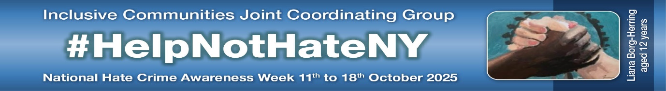

**Hate Crime Word Cloud**

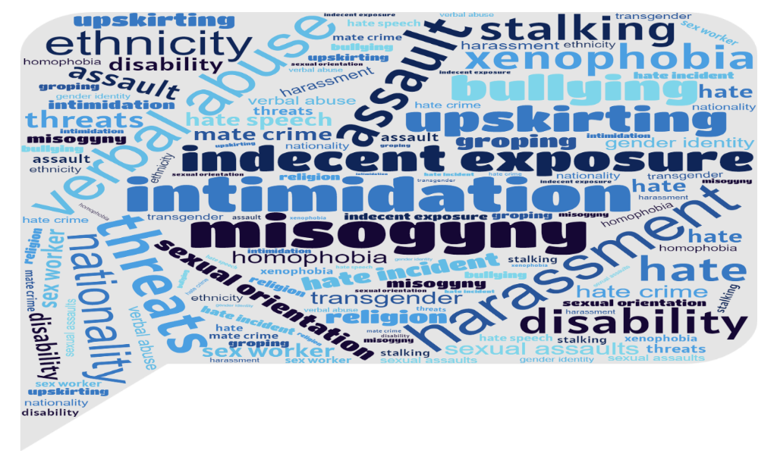

**If you need further information on the webinars outlined above, please contact the key leads listed below.**

**Comms contacts:**

* North Yorkshire Council – Romy Anderson [romy.anderson@northyorks.gov.uk](mailto:romy.anderson@northyorks.gov.uk)
* City of York Council - Megan Rule [megan.rule@york.gov.uk](mailto:megan.rule@york.gov.uk)
* North Yorkshire Community Safety Partnership/Inclusive Communities JCG - Lesley Gray lesley.gray@northyorks.gov.uk
* North Yorkshire Police - [greig.tindall@northyorkshire.police.uk](mailto:greig.tindall@northyorkshire.police.uk)
* NY Adults Safeguarding Board - [nysab@northyorks.gov.uk](mailto:nysab@northyorks.gov.uk)
* NY Safeguarding Children’s Partnership – [Hannah.Ellingworth@northyorks.gov.uk](mailto:Hannah.Ellingworth@northyorks.gov.uk)
* York Children’s Safeguarding Partnership - [joanna.williamson@york.gov.uk](mailto:joanna.williamson@york.gov.uk)
* York Safeguarding Adults Board – Catherine Law [catherine.law@york.gov.uk](mailto:catherine.law@york.gov.uk)
* York and North Yorkshire Combined Authority - [amanda.bowers@yorknorthyorks-ca.gov.uk](mailto:amanda.bowers@yorknorthyorks-ca.gov.uk) and [simon.jones@yorknorthyorks-ca.gov.uk](mailto:simon.jones@yorknorthyorks-ca.gov.uk)