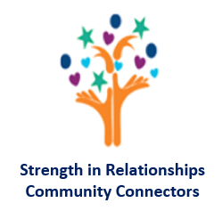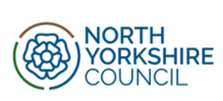

**Introduction to Children Law**

**On-line course (6 Modules)**

**Exciting News from North Yorkshire Children and Families Service!**





North Yorkshire Children and Families Service are excited to launch their new NYES [North Yorkshire Education Services] landing page. Please Scan the QR opposite.

**The aim of the Children and Families Service – Early Help page is to ensure information is relevant and accessible for those supporting children, young people, and their families.**

The information available supports the guidance within Working Together to Safeguard Children 2023, ensuring that families receive well-informed responses that prioritise safety and wellbeing of the child, young person, and their family. The new landing page enables agencies to have access to key information and resources, supporting them in their delivery of early interventions and ensuring children and their families receive consistent and empathic responses providing the “right support at the right time by the right person”.

The landing page contains evidence-based tools that support a signs of safety and strength in relationships approach when working with children and their families.

The landing page offers information on a range of topics such as parenting, parental conflict, FEAST and Psychologically Informed Partnership Approach (PIPA). An ideal and easy to navigate tool for schools and early years practitioners ensuring a supportive and consistent approach when working with children and families in North Yorkshire.

**You can also find the link** [**here**](https://eur02.safelinks.protection.outlook.com/?url=https%3A%2F%2Fnyes.info%2FEarlyHelp&data=05%7C02%7CSimone.Wilkinson%40northyorks.gov.uk%7C39490ab58ad74910c17e08dcd3debcb2%7Cad3d9c73983044a1b487e1055441c70e%7C0%7C0%7C638618200800078296%7CUnknown%7CTWFpbGZsb3d8eyJWIjoiMC4wLjAwMDAiLCJQIjoiV2luMzIiLCJBTiI6Ik1haWwiLCJXVCI6Mn0%3D%7C0%7C%7C%7C&sdata=8a3XwpvPWxWogPZAVAyX5%2FSRZQWl1U5JXwTnzOuwTgg%3D&reserved=0)**.**

The landing page can be used for signposting families to the most appropriate resource at the earliest opportunity therefore reducing the need for further referrals and targeted interventions at a later point. This is a more beneficial solution for both families and educational professionals.

When effectively used, the suite of early intervention tools can enable children and their families build resilience, identify their own networks of support, and explore their own solutions to emerging worries.

Having tools and links available in one easy to navigate place will build staff confidence in the information shared with families and will reduce time spent searching for resources.

**Barbara Merrygold [Head of Children and Families Service, Early Help]**

**“This new Early Help landing page provides a suite of information & resources to support all practitioners in their work, ensuring we provide consistent messages, use consistent language and take consistent approaches to delivering a service to the children and families we work with. We have added key information that we feel supports our work and more sections will be added over time”.**





**We are keen to hear your feedback, if you have any comments about the Early Help pages, please contact** [**Simone.wilkinson@northyorks.gov.uk**](mailto:Simone.wilkinson@northyorks.gov.uk)**. Thank you**

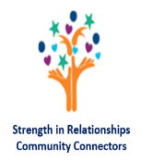

**We would like YOU to consider joining us as an**

**Early Help Volunteer | Community Connector**